# C:\Documents and Settings\Administrator\Application Data\Tencent\Users\181971730\QQ\WinTemp\RichOle\ALR(LOVFO4AX~H1_G2G_[D7.jpg

# **课程设计报告**

课 程 名 称： Database management system

课程设计名称：Database Application Design

系部名称：International Education Center

学生姓名：Arafat Hoshen

班 级：class 3

学 号： 2……………

成 绩：

指导教师：**卢山群**

开课时间：2019-2020学年第2学期

CAEN Customer Service Request (CSR) Database

# **Database Application Design**

**Database Structure**

The database consists of twelve tables. The main CAEN Customer Service Request (CSR) Database Table Structure, Create file and SQL Table Descriptions.

|  |  |
| --- | --- |
| **DATABASE TABLE** | **DESCRIPTION** |
| contact | Contains all of the customer’s information. |
| equipment | Contains information about the piece of equipment that has been submitted for repair. |
| repair | Contains detailed information about the repair problem on a particular piece of equipment. |
| repair\_activity | Serves as the main linking table for other tables by containing the foreign keys of the other tables. |
| repair\_equipment | Contains information about the type of equipment received for  repair (i.e. desktop, printer, laptop). |
| repair\_notes | Contains the shop notes for the repair. |
| repair\_other | Contains additional information related to the repair that may or may not exist for each repair. |
| repair\_staff | Contains password/uniqname information about the CAEN Service Center staff. |
| repair\_status | Contains information about the current status of the repair. |
| repair\_techs | Contains information about which technician is associated with a repair. |
| repair\_type | Contains information about the type of repair, used for  tracking purposes (i.e. personal, CAEN computer, student, department). |
| repair\_vendor | Contains information about vendors (i.e. Dell, HP, Apple). |

Functionality

The database and web application allow technicians to complete the following functions:

Enter a new customer service request form

Modify an existing customer service request form

The database is password-protected and requires a login. There is also session control that automatically logs out the staff person if the session is idle for too long.

The application and database also allow the manager of the service center to generate counts in reports by vendor name, repair type and device type, as well as manage the table data.

**Database Design Process**

Our basic approach for the database project was to take an existing basic prototype (developed in PHP/mySQL) and optimize the database design. Our goal was to develop it with Oracle and JSP. We began the project by doing some planning, design, and review of the existing prototype. Our next step was to meet with one of the Oracle DBAs for CAEN to discuss the current Oracle structure we would have to design around. After several meetings, it became apparent that it would be a pretty complicated process to get the project done this way by the end of the semester and required a lot more Oracle skills than we currently had. We determined that the best course of action was to optimize the database design and web application as a stand-alone application so that it was at least ready for use.

We developed nine new tables and restructured one of the existing tables. Our table design provides future flexibility for growth and changes to the database tables. For example, the repair\_activity table was created to allow for an easy way to add a new table representing activity to be tracked that is related to the repair\_activity table through the addition of a foreign key from the newly created table.

We reworked the code to integrate it with the new tables, improved the basic layout and functionality, and allowed for a more object-oriented approach where pieces of code can be re- used. We accomplished this in PHP with the use of ‘include’ statements.

We learned several important lessons through the design process. These include:

1. Designing your tables is the most important step and must be done early in the project.
2. Building a database and web application from scratch is often easier than revising an existing database and application – which is why initial design is so important and was stressed throughout the course!
3. Being able to design a database well for a client requires a lot of understanding about the business process and needs behind the applications.

**Appendices**

# **Appendix A: CAEN Customer Service Request (CSR) Database Table Structure Appendix B: Create File (do at end)**

# **Appendix C: SQL Table Descriptions**

# **Appendix E: Acknowledge**

# **Appendix A: CAEN Service Center Repair Table Structure**

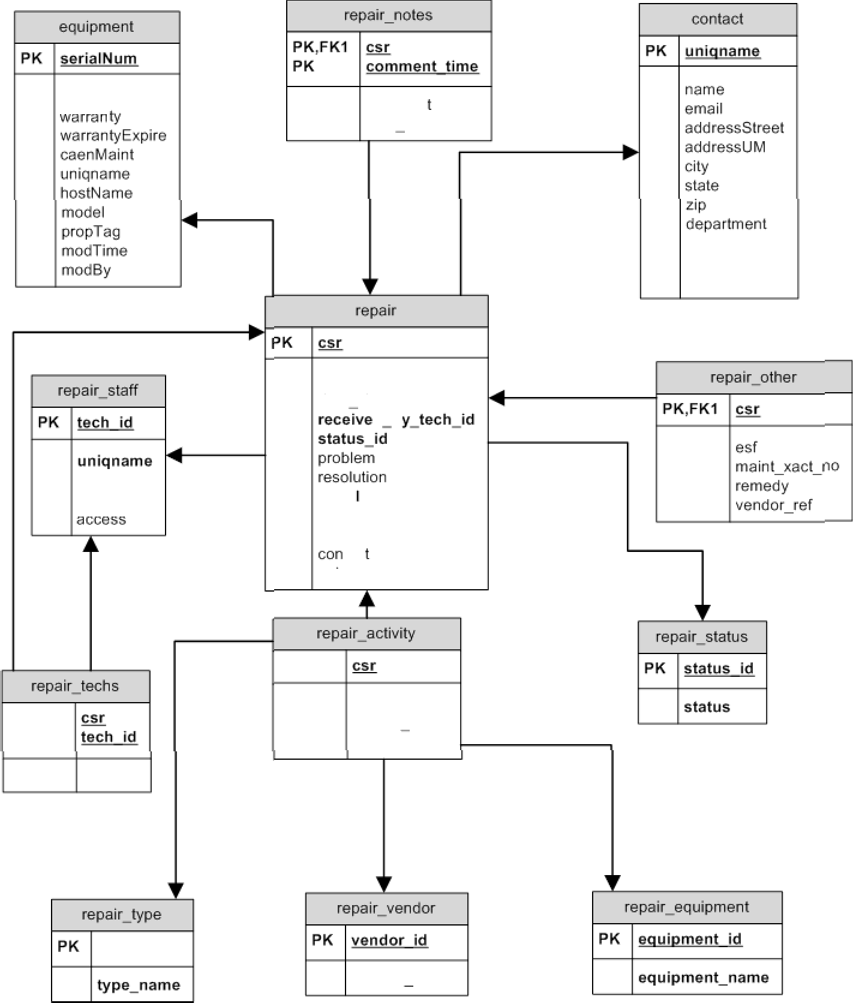

U3 n Q O F

commer

tech id

phr›ne modTime modBy

date open dare close

d b

F K1

F K4 seri a no

F K2 u pdated by tech id u pdated dt

F K3 tac

unic name

PK,FK1

PK,FH1 PK,FHZ

I K2

I KJ

I K'1

type id vendor id

ec uipment id

vendor name

# **Appendix B: Create File**

-- MySQL dump 9.08

--

-- Host: localhost Database: caen

-

-- Server version 4.0.14-standard

--

-- Current Database: caen

--

-- CREATE DATABASE /\*!32312 IF NOT EXISTS\*/ caen;

-- USE caen; USE dinoa;

--

-- Table structure for table 'contact'

--

CREATE TABLE contact (

uniqname varchar(10) NOT NULL default '', name varchar(30) NOT NULL default '', email varchar(30) NOT NULL default '', addressStreet text,

addressUM varchar(30) default NULL, city varchar(20) default NULL, state char(2) default NULL,

zip varchar(10) default NULL, department varchar(30) default NULL, phone varchar(25) NOT NULL default '', modTime timestamp(10) NOT NULL,

modBy smallint(6) default NULL, PRIMARY KEY (uniqname)

) TYPE=MyISAM;

--

-- Dumping data for table 'contact'

--

INSERT INTO contact VALUES ('tester1','Tester One','tester1@umich.edu','Street Address 1','2335B Media Union','Ann Arbor','AZ','48109-2094','CAEN - Labs - MediaU','(734)

615-1234','0311300921',1);

INSERT INTO contact VALUES ('dinoa','Dino Anastasia','dinoa@umich.edu','2281 Bonisteel Blvd.','2335B Media Union','Ann Arbor','MI','48109-2094','CAEN','(734) 615- 5995','0311301044',1);

INSERT INTO contact VALUES ('tester2','Tester Two','tester2@bob.com','Street Address 2','1318 Markley','Ypsilanti','MI','48187','Physics','876-0987','0312061636',1);

INSERT INTO contact VALUES ('tester3','Tester Three','tester3@bob.com','Street Address 3','3505 South Quad','Ann Arbor','MI','48107','Personal','(847) 765-

0983','0402161055',1);

INSERT INTO contact VALUES ('tester4','Tester Four','tester4@bob.com','312 S. State St.','422 Michigan Union','Ann Arbor','MI','48109','Astrology','5- 9876','0312061637',1);

INSERT INTO contact VALUES ('tester5','Tester Five','tester5@bob.com','','1404 Media Union','','','2094','Engin-MSE','647-2112','0312061638',1);

INSERT INTO contact VALUES ('tester6','Tester Six','tester6@umich.edu','Street Address 6','tester6 Address 2','tester6 City','MI','48109','tester6 Department','(800) 55F- Test','0312081035',1);

INSERT INTO contact VALUES ('tester7','Tester Seven','tester7@umich.edu','','','','','','Sites','5-8173','0312081041',1);

--

-- Table structure for table 'equipment'

--

CREATE TABLE equipment (

serialNum varchar(20) NOT NULL default '', vendor varchar(20) NOT NULL default '', warranty char(1) NOT NULL default '', warrantyExpire date default NULL, caenMaint varchar(5) default NULL, uniqname varchar(10) default NULL, hostName varchar(20) default NULL,

model varchar(30) default NULL, propTag varchar(7) default NULL, modTime timestamp(10) NOT NULL, modBy smallint(6) default NULL, PRIMARY KEY (serialNum)

) TYPE=MyISAM;

--

-- Dumping data for table 'equipment'

--

INSERT INTO equipment VALUES ('serialnum2','Apple','y','0000-00- 00','lvl1','dinoa','rivendell','PowerBook G4/500','a675987','0311301432',1); INSERT INTO equipment VALUES ('serialnum1','Apple','y','2005-12- 25','','tester1','','G5/dual2G','','0312052051',3);

INSERT INTO equipment VALUES ('serialnum3','Sun','n','2004-11- 26','','dinoa','yule','Blade 1500','a657895','0311301608',1);

INSERT INTO equipment VALUES ('serialnum5','Dell','n','0000-00- 00','lvl2','tester4','mu3sp01','GX270/3.2G','','0311301517',1);

INSERT INTO equipment VALUES ('serialnum4','Dell','y','2004-12- 15','lvl3','tester2','biggy','GX270','','0312052044',3);

INSERT INTO equipment VALUES ('serialnum6','Dell','Y','2004-07- 01','lvl9','tester6','tester6host','tester6','Atest','0312081035',1); INSERT INTO equipment VALUES ('serialnum7','Dell','N','0000-00- 00','','tester7','aha3','','','0312081041',1);

# **Appendix C: SQL Table Descriptions**

mysql> describe contact;

+ + + + + + +

| Field | Type | Null | Key | Default | Extra |

+ + + + + + +

|  |  |  |  |  |  |  |  |  |  |  |  |
| --- | --- | --- | --- | --- | --- | --- | --- | --- | --- | --- | --- |
| | | uniqname | | | varchar(10) | | |  | | | PRI | | |  | | | | |
| | | name | | | varchar(30) | | |  | | |  | | |  | | | | |
| | | email | | | varchar(30) | | |  | | |  | | |  | | | | |
| | | addressStreet | | | text | | | YES | | |  | | | NULL | | | | |
| | | addressUM | | | varchar(30) | | | YES | | |  | | | NULL | | | | |
| | | city | | | varchar(20) | | | YES | | |  | | | NULL | | | | |
| | | state | | | char(2) | | | YES | | |  | | | NULL | | | | |
| | | zip | | | varchar(10) | | | YES | | |  | | | NULL | | | | |
| | | department | | | varchar(30) | | | YES | | |  | | | NULL | | | | |
| | | phone | | | varchar(25) | | |  | | |  | | |  | | | | |
| | | modTime | | | timestamp(10) | | | YES | | |  | | | NULL | | | | |
| | | modBy | | | smallint(6) | | | YES | | |  | | | NULL | | | | |

+ + + + + + +

12 rows in set (0.00 sec)

mysql> describe equipment;

+ + + + + + +

| Field | Type | Null | Key | Default | Extra |

+ + + + + + +

|  |  |  |  |  |  |  |  |  |  |  |  |
| --- | --- | --- | --- | --- | --- | --- | --- | --- | --- | --- | --- |
| | | serialNum | | | varchar(20) | | |  | | | PRI | | |  | | | | |
| | | vendor | | | varchar(20) | | |  | | |  | | |  | | | | |
| | | warranty | | | char(1) | | |  | | |  | | |  | | | | |
| | | warrantyExpire | | | date | | | YES | | |  | | | NULL | | | | |
| | | caenMaint | | | varchar(5) | | | YES | | |  | | | NULL | | | | |
| | | uniqname | | | varchar(10) | | | YES | | |  | | | NULL | | | | |
| | | hostName | | | varchar(20) | | | YES | | |  | | | NULL | | | | |
| | | model | | | varchar(30) | | | YES | | |  | | | NULL | | | | |
| | | propTag | | | varchar(7) | | | YES | | |  | | | NULL | | | | |
| | | modTime | | | timestamp(10) | | | YES | | |  | | | NULL | | | | |
| | | modBy | | | smallint(6) | | | YES | | |  | | | NULL | | | | |

+ + + + + + +

11 rows in set (0.00 sec)

mysql> describe repair;

+ + + + + + +

| Field | Type | Null | Key | Default | Extra |

+ + + + + + +

|  |  |  |  |  |  |  |  |  |  |  |  |  |
| --- | --- | --- | --- | --- | --- | --- | --- | --- | --- | --- | --- | --- |
| | | csr | | | int(11) | | |  | | | PRI | | | NULL | | | auto\_increment | | |
| | | date\_open | | | date | | |  | | |  | | | 0000-00-00 | | |  | | |
| | | date\_close | | | date | | | YES | | |  | | | NULL | | |  | | |
| | | received\_by\_tech\_id | | | smallint(6) | | | YES | | |  | | | NULL | | |  | | |
| | | status\_id | | | tinyint(4) | | |  | | |  | | | 0 | | |  | | |
| | | problem | | | text | | | YES | | |  | | | NULL | | |  | | |
| | | resolution | | | text | | | YES | | |  | | | NULL | | |  | | |
| | | serialno | | | varchar(20) | | | YES | | |  | | | NULL | | |  | | |
| | | contact | | | varchar(10) | | |  | | |  | | |  | | |  | | |
| | | updated\_by\_tech\_id | | | smallint(6) | | |  | | |  | | | 0 | | |  | | |
| | | updated\_dt | | | timestamp(10) | | | YES | | |  | | | NULL | | |  | | |

+ + + + + + +

11 rows in set (0.00 sec)

mysql> describe repair\_activity;

+ + + + + + +

| Field | Type | Null | Key | Default | Extra |

+ + + + + + +

|  |  |  |  |  |  |  |
| --- | --- | --- | --- | --- | --- | --- |
| | csr | | int(11) | | | | PRI | | 0 | | | | |
| | type\_id | | tinyint(4) | | | | | | 0 | | | | |
| | vendor\_id | | tinyint(4) | | | | | | 0 | | | | |

| equipment\_id | tinyint(4) | | | 0 | |

+ + + + + + +

4 rows in set (0.00 sec)

mysql> describe repair\_equipment;

+ + + + + + +

| Field | Type | Null | Key | Default | Extra |

+ + + + + + +

| equipment\_id | tinyint(4) | | PRI | NULL | auto\_increment |

| equipment\_name | varchar(50) | | | | |

+ + + + + + +

2 rows in set (0.00 sec)

mysql> describe repair\_notes;

+ + + + + + +

| Field | Type | Null | Key | Default | Extra |

+ + + + + + +

| csr | int(11) | | PRI | 0 | |

| comment\_time | timestamp(10) | YES | PRI | NULL | |

| comment | text | YES | | NULL | |

| tech\_id | smallint(6) | | | 0 | |

+ + + + + + +

1. rows in set (0.00 sec)

mysql> describe repair\_other;

+ + + + + + +

| Field | Type | Null | Key | Default | Extra |

+ + + + + + +

|  |  |  |  |  |  |
| --- | --- | --- | --- | --- | --- |
| | csr | | int(11) | | | | PRI | 0 | | | | |
| | esf | | varchar(10) | | YES | | | NULL | | | | |
| | maint\_xact\_no | | varchar(15) | | YES | | | NULL | | | | |
| | remedy | | varchar(15) | | YES | | | NULL | | | | |
| | vendor\_ref | | varchar(25) | | YES | | | NULL | | | | |

+ + + + + + +

1. rows in set (0.00 sec)

mysql> describe repair\_staff;

+ + + + + + +

| Field | Type | Null | Key | Default | Extra |

+ + + + + + +

| tech\_id | smallint(6) | | PRI | NULL | auto\_increment |

| uniqname | varchar(10) | | | | |

| name | varchar(30) | | | | |

| password | varchar(20) | | | | |

| access | char(1) | YES | | NULL | |

+ + + + + + +

5 rows in set (0.00 sec)

mysql> describe repair\_status;

+ + + + + + +

| Field | Type | Null | Key | Default | Extra |

+ + + + + + +

| status\_id | tinyint(4) | | PRI | NULL | auto\_increment |

| status | varchar(20) | | | | |

+ + + + + + +

2 rows in set (0.00 sec)

mysql> describe repair\_techs;

+ + + + + + +

| Field | Type | Null | Key | Default | Extra |

+ + + + + + +

| csr | int(11) | | PRI | 0 | |

| tech\_id | smallint(6) | | PRI | 0 | |

+ + + + + + +

2 rows in set (0.01 sec)

mysql> describe repair\_type;

+ + + + + + +

| Field | Type | Null | Key | Default | Extra |

+ + + + + + +

| type\_id | tinyint(4) | | PRI | NULL | auto\_increment |

| type\_name | varchar(50) | | | | |

+ + + + + + +

2 rows in set (0.00 sec)

mysql> describe repair\_vendor;

+ + + + + + +

| Field | Type | Null | Key | Default | Extra |

+ + + + + + +

| vendor\_id | tinyint(4) | | PRI | NULL | auto\_increment |

| vendor\_name | varchar(50) | | | | |

+ + + + + + +

2 rows in set (0.00 sec)

# **Acknowledge**

I would like to express my special thanks of gratitude to my teacher 卢山群 laoshi as well as our principal 卢山群 who gave me the golden opportunity to do this wonderful project on the topic making databade priject.which also helped me in doing a lot of Research and i came to know about so many new things I am really thankful to them.

Secondly i would also like to thank my parents and friends who helped me a lot in finalizing this project within the limited time frame.